Science is about looking at the world around you and trying to understand why things are as they are. Scientists have been asking questions and looking for answers for centuries. They still are!

You are going to follow through what is called ‘the scientific method’ when trying to answer a question.


Decide what idea you would like to investigate and write it down. There are some ideas at the end of these instructions to help get you thinking of your own experiment.

- Hypothesis


A hypothesis is an idea that might answer this question and explain what is happening. Write one idea in your exercise book. This idea together with a possible explanation is your hypothesis. Hypotheses should be testable.

- How will you test if your idea is correct?

Write down, briefly, what you could do to see if your idea is right.

- Prediction

What do you predict will be the outcome of your experiment? This is your prediction. Predictions do not need to have an explanation.

- Testing

Scientists carry out an experiment to prove or disprove their ideas.
Think about how you would carry out the experiment.
Discuss what your method will be? Is it a fair test?

Fair testing :
To be sure that the test is fair you should only change one thing this is known as the independent variable.
The thing that you measure is called the dependent variable.
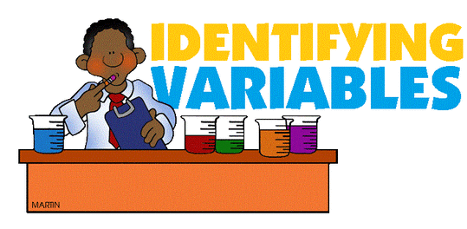
- What is the independent variable in your experiment?

- Which other variables will you control (keep the same)?

- What is the dependent variable in your experiment?

- Method

Write a numbered list of instructions to describe how you will be carrying out your investigation. You can include a diagram of any equipment you need to use.
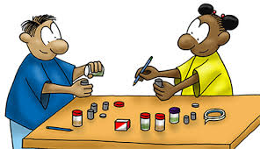

- Conclusion


When you have performed your experiment, you will have to decide whether or not your hypothesis is right. Did your experiment work out as you predicted? This is your conclusion.

You may need to go back to the drawing board and test out some new ideas. When you find an idea that’s correct you have discovered something new for yourself. This is how scientists add knowledge for everyone to benefit from.

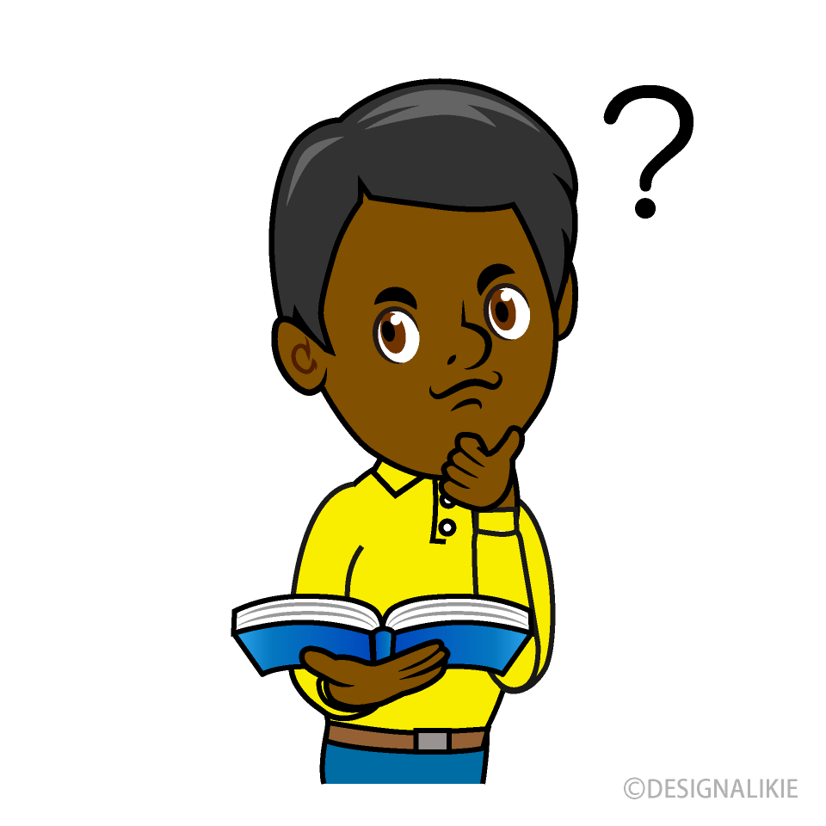
- Evaluation

How could improve your experiment if you were to do it again?

- Further ideas to test.
Has your experiment given you any ideas for further testing, linked to your original hypothesis?

Here is a completed example to help you think of some ideas. At the very end is another list of possible ideas, but get creative and do whatever you are interested in. Please make sure your parents or carers know what you are planning to do and make sure it is safe!

Question: Does my dog prefer squeaky toys to stuffed toys?

- Hypothesis

My dog will prefer the squeaky toy as the noise gets his attention and it is more like a real animal.
- How will you test if your idea is correct?

I will ask my dog to sit and stay, then place two toys in front of him – one will be a squeaky toy and the other a stuffed animal. I will let him go and see which toy he picks up and plays with first.

- Prediction

I predict that my dog will choose the squeaky toy more often than the stuffed animal.
- Testing

- What is the independent variable in your experiment?

I will change whether the toy is squeaky or stuffed.

- Which other variables will you control (keep the same)?

I will keep the toys the same distance away from my dog each time.

- What is the dependent variable in your experiment?

I will record how many times he picks each type of toy.

- Method

1. Person 1 asks dog to sit and holds him by his collar.
2. Person 2 places two toys 2 metres in front of the dog (one squeaky toy and one stuffed toy).
3. Person 1 releases the dog and writes down which toy he goes to first.
4. Repeat nine more times to give ten sets of results in total.

- Conclusion

My experiment did work as expected – my dog chose the squeaky toy seven times out of ten (70% of the time). This means he showed a preference for the squeaky toys.
- Evaluation

How could improve your experiment if you were to do it again?

To improve the experiment, I should try to test more dogs to see if it is a reproducible effect. I should also try a range of toys that my dog is not familiar with to avoid him always picking his one favourite toy.

- Further ideas to test.
Do dogs prefer toys that are particular colours?

Other ideas to get you thinking of your own experiment:

- Is sugar more difficult to dissolve than salt?
- Do sugar lumps dissolve quicker than granulated sugar?
- Does memory get worse with age?
- Build a simple ‘land boat’ using an empty match box, cocktail stick and paper sail. Does the size of the sail affect distance travelled when blown with a hairdryer?
- Do plants growing in the shade have bigger leaves than ones growing in the light?
- Do snails/woodlice prefer living in the sun or shade?
- Which materials float or sink?
- Do people’s reaction times get slower with age?
- Does the size of a magnet affect how strong it is?

Be creative and have fun, but….

Please ensure that you have checked with an adult before trying any experiments. Make sure you have thought carefully about any risks involved, particularly if the experiment involves heat, breakable or sharp objects, or electricity. DO NOT attempt to mix any type of cleaning product as part of an investigation.

