A Level German

Transition Booklet



I have specifically written this transition pack to help you make the best start to your German A-level studies in September. A-level German is difficult, but also immensely rewarding and enjoyable!

A good grammatical knowledge is probably the best preparation you can do, so I’ve prepared 5 sections, practising and reinforcing 5 key grammatical points which you have hopefully been introduced to/some experience, but maybe not embedded yet. I’ve also included 4 reading tasks, some links to and advice on listening activities and finally some additional activities/links if you have more time.

Remember - I am looking for accuracy! Using internet translators (other than for possibly single words) or AI is not acceptable and will not help you ultimately in your German studies.

Viel Gluck!

Section 1: Grammar

1. The (past) Imperfect Tense in German

The imperfect tense is generally used in more formal written German – in reports, stories, newspapers.

The imperfect Tense can also be used for

1. Actions that were repeated regularly or habitually.

(The perfect tense is more a one-off event that happened)

* Als ich jünger war, **spielte** ich Tennis jede Woche.

Write in English -

1. Actions that set the stage for another past tense event

* Es **regnete,** als ich zu Fuss nach Hause gegangen bin.

Write in English -

1. Commonly with the verbs “haben”, “sein”, “geben and modal verbs. Write these in English-

Es hatte

Wir waren

Es gab

Ich konnte

Ich musste

Wir wollten

The imperfect tense is really easy to form.

Regular verbs

| Ich spiel**te** | I played/ I was playing/ I used to play |
| --- | --- |
| Du spiel**test** | You played/ you were playing/ You used to play |
| Er/sie/es spiel**te** | He/she/it played/ He/she/it was playing/ He/she/it used to play |
| Wir/sie spiel**te** | We/they played/ We/they were playing/ We/they used to play |

Write the imperfect tense for these verbs in the “ich” form only.

They are all regular so follow the pattern above as for spielen.

| spielen | Ich spiel**te** | I played/ I was playing/ I used to play |
| --- | --- | --- |
| lernen |  | I learnt/was learning/used to learn |
| machen |  | I did/was doing/used to do |
| kaufen |  | I bought/was buying/used to buy |
| hören |  | I listened/was listening/used to listen |

Now find the imperfect forms for these verbs below. They are all irregular so do not follow the pattern above. You will find them in the back of the dictionary in the verb tables section.

| sehen | I watched/was watching/used to watch |  |
| --- | --- | --- |
| trinken | I drank/was drinking/used to drink |  |
| nehmen | I took/was taking/used to take |  |
| finden | I found/was finding/used to find |  |
| geben | I gave/was giving/used to give |  |
| beginnen | I began/was beginning/used to begin |  |
| denken | I thought, was thinking/used to think |  |
| werden | I became/was becoming/used to become |  |
| gehen | I went/was going/used to go |  |
| fahren | I travelled/was travelling/used to travel |  |

2. Tenses!

Try to put these verb forms into German using the first person singular (ich) Some have been filled in to help you. Also write in the English

| INFINITIVE | Present Tense | Imperfect Tense | Perfect Tense | Future Tense | Conditional Tense |
| --- | --- | --- | --- | --- | --- |
| spielen |  |  |  |  | Ich w*ũ*rde spielen  I would play |
| lernen |  | ich lernte  I learnt/ was learning/used to learn |  |  |  |
| sehen |  |  | Ich habe…gesehen  (I have seen) |  |  |
| gehen |  |  |  |  |  |
| fahren |  | Ich fuhr  I travelling/was travelling/used to travel | Ich bin…..gefahren  I have travelled (I am travelled) |  |  |

# 3. Pronouns and possessive adjectives

| PERSONAL PRONOUN | ENGLISH  (Nominative) | MASCULINE | FEMININE | NEUTER | PLURAL |
| --- | --- | --- | --- | --- | --- |
|  | the | der | die | das | die |
|  | a | ein | eine | ein |  |
|  |  |  |  |  |  |
| ich | MY | mein | meine | mein | meine |
| du | YOUR | dein | deine | dein | deine |
| er | HIS | sein | seine | sein | seine |
| sie | HER | ihr | ihre | ihr | ihre |
| es | IT’S | sein | seine | sein | seine |
| wir | OUR | unser | unsere | unser | unsere |
| sie | THEIR | ihr | ihre | ihr | ihre |
| Sie | YOUR | Ihr | Ihre | Ihr | Ihre |

Put into German

1. My favourite month is August. (Der Monat)
2. My favourite film is Shrek (Der Film)
3. My favourite animal is a dog. (Das Tier)
4. My favourite teacher is Mrs McCavish (die Lehrerin)
5. His favourite football team is Bayern Munich. (Die Mannschaft)
6. Her favourite subject is German. (Das Fach)
7. Our favourite colour is red. (die Farbe)
8. Their favourite day is Friday. (Der Tag)
9. His favourite book is Harry Potter. (Das Buch)

4. Word order



Write new sentences with the correct Time-Manner-Place word order, starting with the words in brackets.

EXAMPLE

Ich war den ganzen Tag zu Hause. (*in den Ferien*)

*In den Ferien war ich den ganzen Tag zu Hause*

1. Wir schauen im Wohnzimmer fern. (*abends*)

____________________________________________________________________________________

1. Meine Mutter hatte kein Handy. (*als Teenager*)

____________________________________________________________________________________

1. Dieses Programm können Sie kostenlos downloaden. (*im Internet*)

____________________________________________________________________________________

1. Ich arbeite im Internetcafé. (*im Sommer*)

____________________________________________________________________________________

1. Franka kann nicht im Internet surfen. (*mit ihrem Handy*)

____________________________________________________________________________________

1. Write the following sentences with the correct Time-Manner-Place word order.
2. am Markt – ins Kino – gehen – heute Abend – Sie

____________________________________________________________________________________

1. fährt – zur Schule – Tom – mit dem Fahrrad – jeden Tag

____________________________________________________________________________________

1. nachmittags – Ich – mit Freunden – chatte – auf Facebook

____________________________________________________________________________________

1. in Urlaub – Ich – dieses Jahr – ohne meine Eltern – fahre

____________________________________________________________________________________

1. Meine Oma – im Wohnzimmer – hatte – keinen Fernseher – früher

____________________________________________________________________________________

1. skype – Ich – mit meiner Freundin – jeden Tag – in meinem Zimmer

_________________________________________________________________

5. The nominative, accusative and dative cases in German

Compare these sentences –

| **N**  **A**  **D** | **Der** Bahnhof in Reading ist sehr groβ.  Der Zug fährt durch **den** Bahnhof.  In **dem** (Im) Bahnhof gibt es viele Cafes. |  |  |
| --- | --- | --- | --- |
|  |  |  |  |
| **N**  **A**  **D** | **Die** Stadt heiβt Reading.  Am Samstag bin ich in **die** Stadt gegangen.  In **der** Stadt gibt es viele Geschäfte. |  |  |
|  |  |  |  |
| **N**  **A**  **D** | **Das** Kino ist ganz modern.  Ich gehe oft in **das** (ins) Kino.  In **dem** (Im) Kino sieht man filme. |  |  |

* The nominative case is the case that you have learnt up until now – it is used when the noun is the subject of the sentence.
* The accusative case is used when the noun is the object of the sentence (commonly after “ich habe” and “es gibt” and also after some prepositions.
* The dative case is used when the noun is the indirect object of the sentence (don’t worry about this for now ) and also after some prepositions and after some verbs.
* We also have the genetive case in German. This is used to indicate possession (and can often replace the word ‘of’. We will introduce the genetive case in September.

Prepositions are small words like ‘**in’**, ‘**for**’ and ‘**at**’ in English.

In German prepositions are always followed by the accusative or dative case. This means that the definite and indefinite articles have to change (words for “the” and “a”).

| Definite article | m | f | n | pl |
| --- | --- | --- | --- | --- |
| Nominative | der | die | das | die |
| Accusative | den | die | das | die |
| Dative | dem | der | dem | den |

| indefinite article | m | f | n | pl |
| --- | --- | --- | --- | --- |
| Nominative | ein | eine | ein |  |
| Accusative | einen | eine | ein |  |
| Dative | einem | einer | einem |  |

You can see that for the accusative case, only the masculine words change.

You can also apply the above for the negative “kein” and for possessive adjectives (mein/dein/sein etc)

Some prepositions always take the accusative:

bis gegen

durch ohne

entlang um

für

Some prepositions always take the dative:

ausser nach

bei seit

gegenüber von

mit zu

Look up any of the prepositions above that you don’t know in English and write them in English.

Try to write these correctly in German. Remember – first job is to find out if the noun is der (m), die (f), das (n) or die (pl). Look in the dictionary if you are unsure. DON’T GUESS! Use a dictionary, not an internet translator and do not use AI as I will check your understanding in September.

1. Through the tunnel.
2. Along the river.
3. For my birthday
4. Opposite the library
5. To the train station (zu)
6. From my house

Can you shorten number 5?

Some prepositions can take EITHER the accusative or the dative case depending on the context. These are:

an

auf

in

hinter

neben

über

unter

vor

zwischen

Write down what they mean in English.

They are followed by the ACCUSATIVE when there is movement forwards or towards a place,

Ich gehe in den Supermarkt.

They are followed by the DATIVE when there is no movement towards a place. To indicate where something or someone is,

Ich bin in dem (im) Supermarkt.

ACCUSATIVE DATIVE

Ich gehe in den Park. DER Wir sind in dem Park.

Sie geht in die Schule. DIE Er arbeitet in der Schule.

Wir gehen ins (in das) Kino. DAS Er ist im (in dem) Kino.

Wir gehen zwischen die Geschäfte. DIE Der Bahnhof ist zwischen den Geschäften



n.b - In the dative plural, you also add an “n” to the noun.

Fülle die Lücken aus!

1. Ich bin in__________ Schule. (die)
2. Die Post ist zwischen _________ Bahnhof und ___________ Bäckerei. (der/die)
3. Ich gehe in ________ Stadt. (die)
4. Die Katze geht in _________ Schlafzimmer. (das)
5. Die Kinder spielen auf _________ Schulfeld. (der)
6. Ich sehe fern in __________ Wohnzimmer.(das)
7. Er geht in _______ Blumengeschäft. (das)
8. Ich warte auf dich an _________ Bushaltestelle. (die)
9. Ich lese Bücher in ___________ Bibliothek. (die)
10. Meine Mutter geht jede Woche in ________ Supermarkt. (der)
11. Bist du auf _________ Bahnhof? (der)
12. Die Stadt liegt an ________ Küste.(die)

Section 2:Past reading questions (N20)H

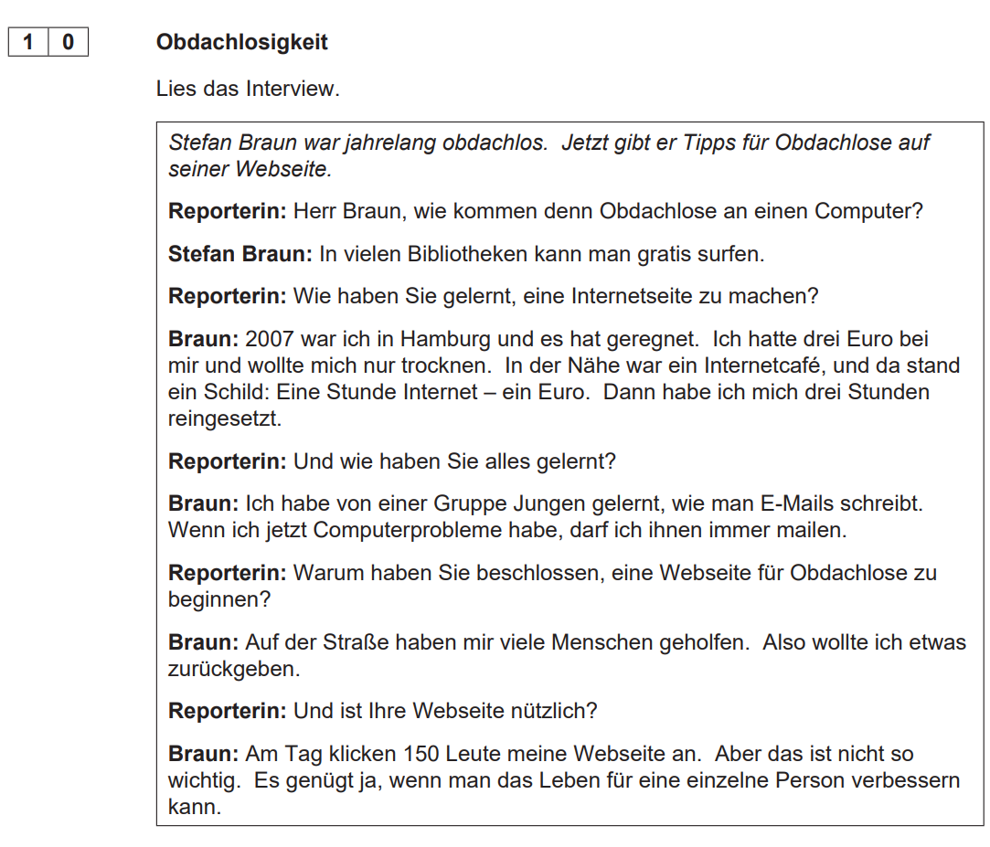

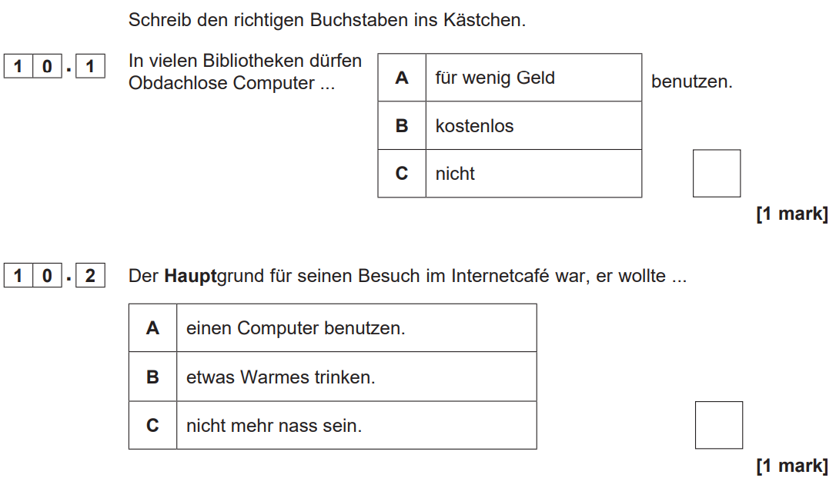

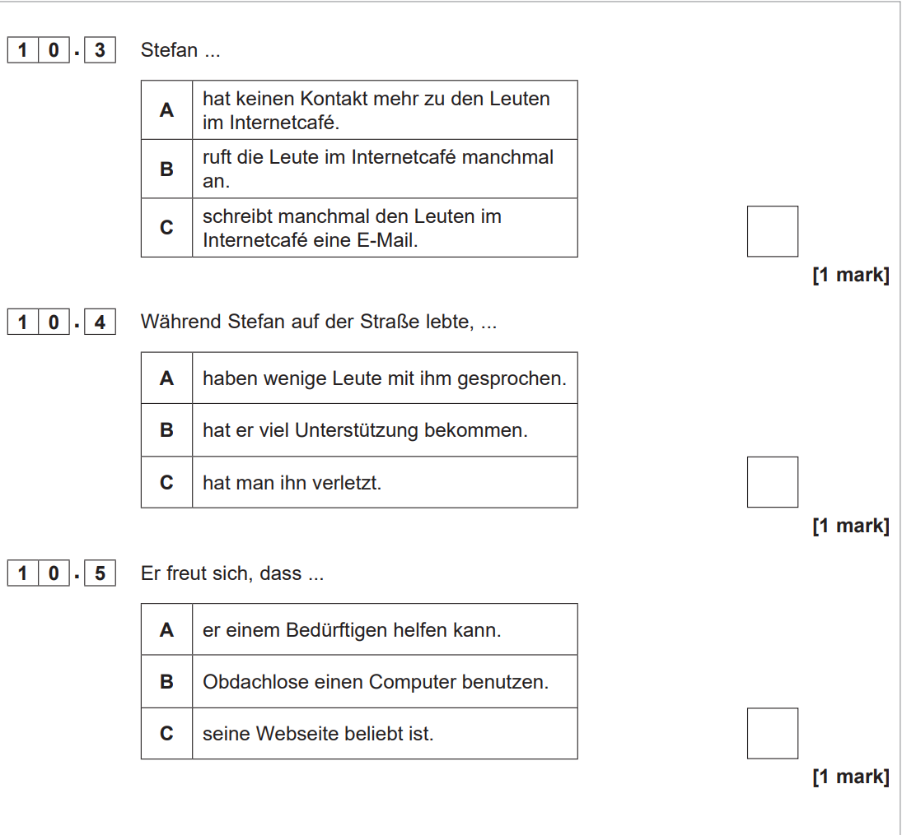

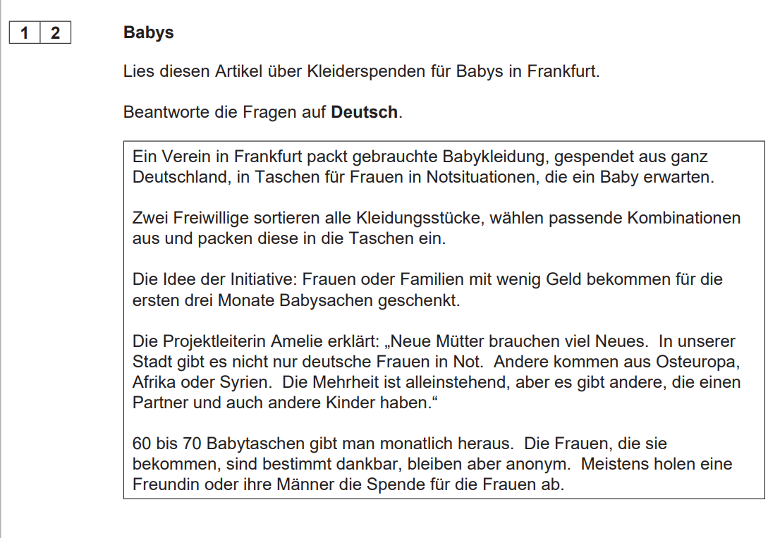

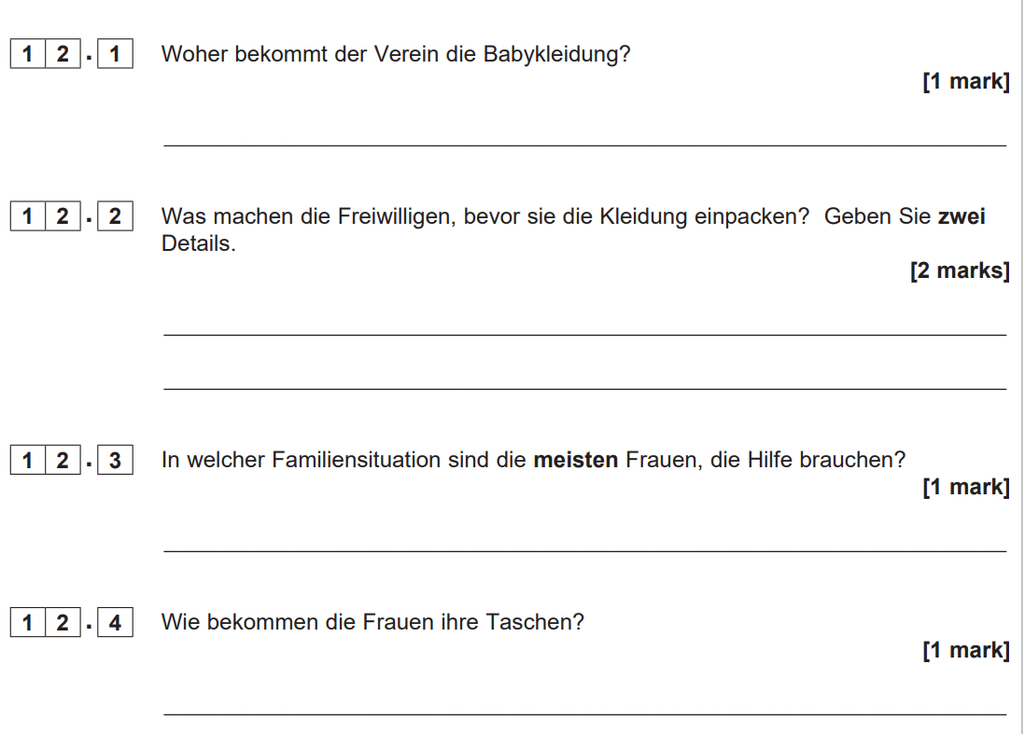

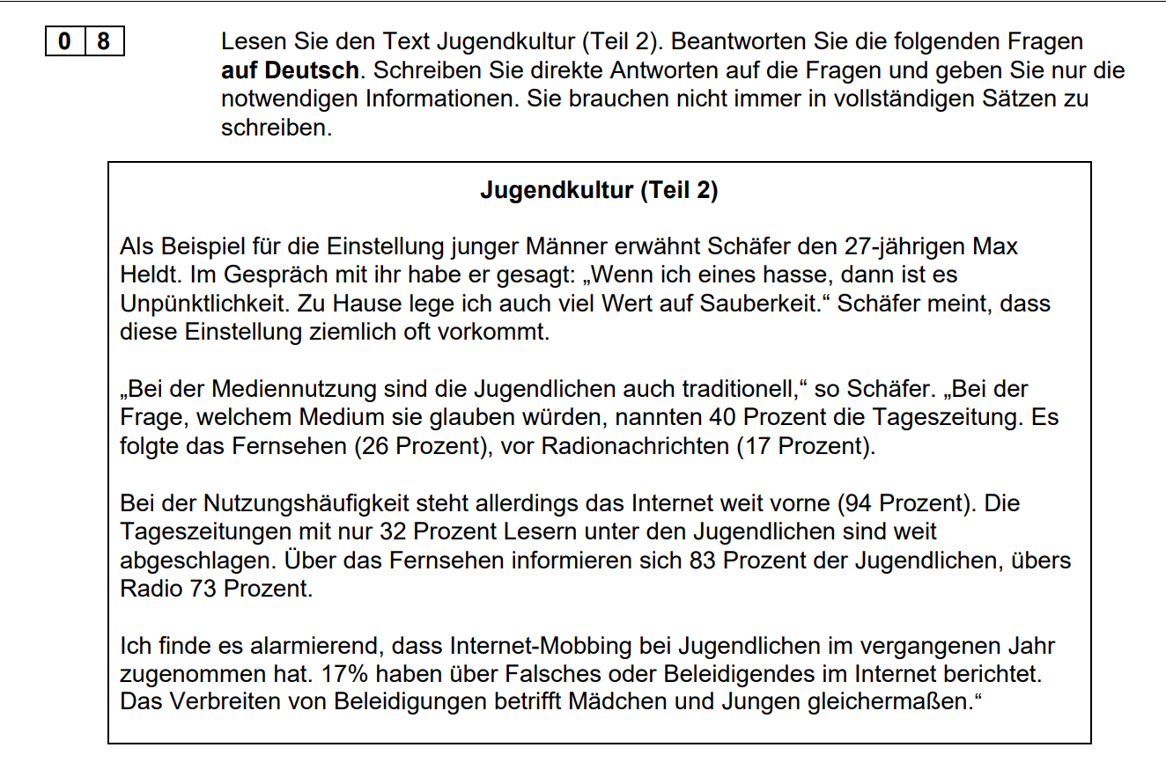

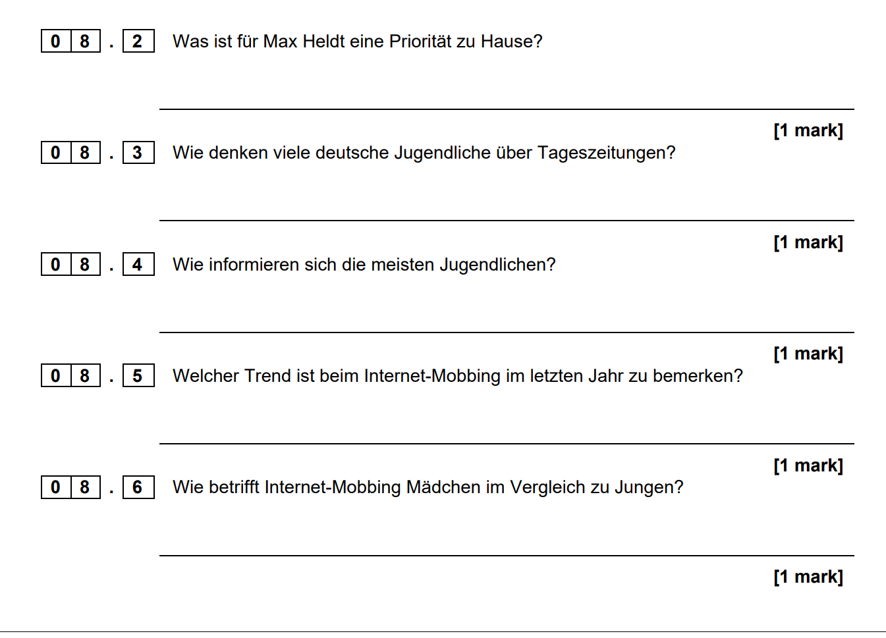

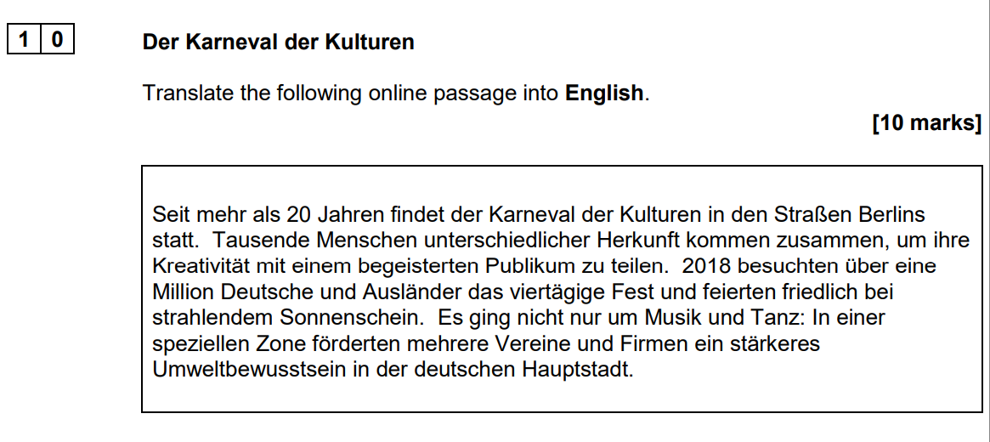

|  |
| --- |
|  |
|  |
|  |
|  |
|  |
|  |
|  |
|  |
|  |
|  |
|  |

Section 1: Additional activities to help you make the best progress

If you are able and have the time, doing some of these exercises (2 or 3 times a week for 20-30 minutes) will really help you in September with your studies and to make great progress.

# Work on your listening skills!

Slowly spoken news (langsam gesprochene Nachrichten)

<https://www.dw.com/de/neueste-videos/s-64431693>

This site is updated each day. It has national and international news, spoken in German but a little slower. If you watch little and often (5-10 minutes every day) over time you will really notice a difference in your ability to understand spoken German. Don’t expect to understand every word, especially at the start. It also has subtitles which is really useful for identifying key words and following along with the audio,

# More grammar?

In order to support your learning, it is really important that you have a good understanding of German grammar. You may feel confident with the grammar you learned at GCSE course (or you might not!), but you will be encountering some more complex grammar in your A-level course. It’s a bit like knowing the rules for a game. You wouldn’t expect to be able to learn the rules easily just by simply watching a sport! You will need to get a grip on grammar!

For a refresher, try this site. This is aimed at GCSE students but if you feel unsure about the basics, this is a good place to start.

<http://www.languagesonline.org.uk/Hotpotatoes/germanindex.htm#Grammar>

If you are unsure about your understanding of grammatical terms, this could be the site for you.

<http://grammarist.com/glossary/>

If you would like a bit of a challenge, here is a link to a great site with more complex grammar exercises.

<http://deutschdrang.com/dir/online-exercises/>

# Even more ideas!

Can you spare 100 seconds every day? Save this site on your phone – it has a daily round up of the news in 100 seconds – listen to it every day!

<http://www.tagesschau.de/100sekunden/>

There are a great number of free Apps which you can download onto your phone to help you with German grammar as well as other areas of language development. Try to find some to use. (eg [Duolingo](https://www.duolingo.com/))

Watch the news in German. This BBc site has links to other news programmes in German. This is a great way to keep up to date with current affairs around the world and in Germany.

<http://www.bbc.co.uk/languages/german/tv/onlinenews.shtml>