Welcome to the Sixth Form
Media Studies Department
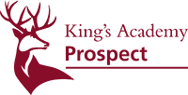

This booklet will provide you with some ideas for your course and some preparation to do for September.

Please have a good look through it so that you know what to expect in September.

We will provide you with the texts you will be studying but you may need to buy your own texts for your NEA/coursework.

So....why Media Studies?

The fundamental objective of the Media Studies curriculum is to equip students with the analytical frameworks necessary to navigate an increasingly mediated world with a critical perspective. In an era saturated with digital content, understanding the mechanisms and influence of the media is paramount for developing civic literacy, challenging dominant narratives, and fostering well-rounded, independent thinkers. Ultimately, this course aims to cultivate the future leaders of a digitally native generation.

Media Studies: Discipline & Scope
Media Studies entails the rigorous exploration of how media shapes reality, influences public perception, and functions as a powerful instrument of social control. Our pedagogical approach empowers students to deconstruct and analyse media texts through five core theoretical pillars: media language, representation, audience, industry, and socio-historical and political contexts. Students examine how media has evolved into the primary conduit for human communication and perception.
Bridging theory and practice, students apply this critical knowledge to the production of their own media artifacts. This dual approach equips them with the high-level digital literacy and technical proficiencies required to excel in a modern, technology-driven workforce, positioning them a step ahead as they begin their careers.
Intellectual debate and critical discourse are foundational to our daily classroom practice. These methods are leveraged to stimulate higher-order thinking, challenge preconceptions, and provide students with a balanced, global perspective. Consequently, students develop the capacity to articulate complex viewpoints with confidence, eloquence, and empathy.

Teaching and Learning
We are committed to ensuring that all students leave school with robust subject knowledge, advanced communication skills, and the capacity to critically evaluate diverse texts. Students will develop high-level competencies in reading, writing, speaking, and listening, enabling them to seamlessly connect theoretical frameworks to contemporary global issues. Through the study of diverse media forms and cultural contexts, students gain a profound appreciation for the power of the media in shaping society, culture, and individual identity.
Graduates of the King’s Academy Prospect Media Studies program will depart as articulate, thoughtful, and autonomous citizens. They will possess the critical acumen and cultural capital necessary to succeed in higher education, employment, and a broad spectrum of future careers.

The Media Studies Questionnaire:

- What television series are you currently watching or have watched recently?

- What was your favourite TV show as a child?

- Do you read magazines? If so, which ones do you read?

- Who was your favourite YouTube channel when you were a child?

- Do you use social media apps such as TikTok, Insta, Facebook? Who do you follow? Any celebrities?

- What genre of music do you listen to? Is there a particular artist you like at the moment?

- Do you ever listen to the radio? If so, what stations?

- Do/have you ever read newspapers?

- What is your favourite television, or print, advert?

- Do you play video games and what are their titles? (mobile, console, PC)

- What is your favourite film?

- What is your least favourite celeb and why?

Media Studies Transition Work
Language
TASK 1: Watch the clip: https://www.youtube.com/watch?v=yuKu6PZXCIY

1. What do you think is the main message of the clip?
2. Using at least two facts from the clip why do you think Media is an important subject to study?

There are 4 main areas of study for A Level Media Studies – Media Language, Representation, Audience, and Industry. These along with theories make up the Media Theoretical Framework.

MEDIA LANGUAGE: Media language refers to how media products communicate with an audience. This is mainly done through the use of visual language. You will find that media texts communicate meaning through the use of signs and symbols. Creators of media products encode messages and meanings within their products through media language, the audience then decode their messages and respond to them in different ways. It can include:

- Camera Angles
- Editing Sound
- Mise-en-scene (what is in the frame)
- Intertextuality (referring to another media product within their own work)
- Genre

TASK 2: Look at this picture of Wayne Rooney from an advertisement for Nike. What meanings does this advert portray to a viewer? Write at least 3 ways that this advert could be interpreted (e.g. what is this advert showing?):


REPRESENTATION
Representation refers to how the media portrays events, issues, individuals and social groups. This covers which different groups, individuals and/or events are presented or shown on the product. The media represents the world. Many theorists such as Stuart Hall and David Gauntlett have explored the notion that the media do not actually reflect the world, but they shape it through their representations.

TASK 4: Watch this short film from the YouTube channel ‘The School of Life’:

https://www.youtube.com/watch?time_continue=8&v=NwPdAZPnk7k Q

Answer this question - Do you think the media offer audiences a fair and non-biased view on the world?
AUDIENCE

Every media product targets a specific audience. Each media product producer has a target audience in mind when creating the product. What would be the point of any media text if there was no audience to consume it? Within Media Studies ‘audience’ refers to how different forms of media target, reach and address audiences. We also explore how to group people into audiences and how these groups respond differently to different media texts.

TASK 3
Look at these two magazine front covers. They are both aimed at specific target audiences.
a) Explain who each magazine is targeted at.
b) Give examples from the front covers to back up the reasons you are giving. For example: Magazine A is aimed at women as there is a large image of a female on the centre of the front cover. Magazine A Magazine B
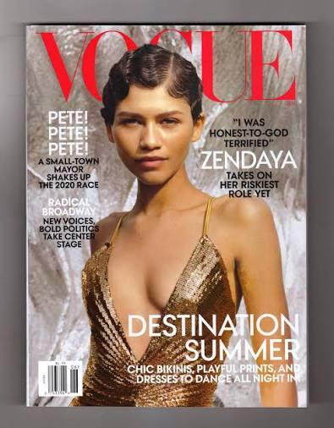
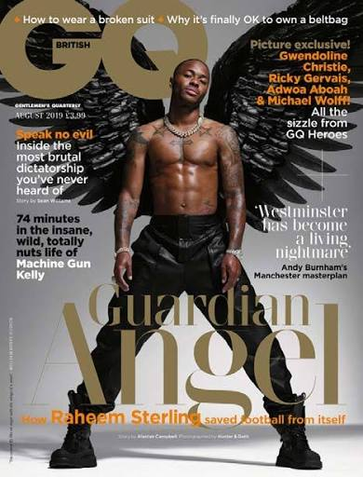

INDUSTRY
Media industries refer to the business aspect of the media. As media students you will be exploring how different media industries produce, distribute and market their products. You will consider ownership, regulation and technological change in the industry. Mainstream media products are often produced by big global conglomerates that have a large amount of power within the industry.

Research the following:

DMG Media: The publishing arm of the Daily Mail and General Trust (DMGT). Their portfolio includes the Daily Mail, The Mail on Sunday, Metro, and the i.

Look at their products. Can you spot a pattern emerging between all their media products? Is there a danger to audiences not knowing that one company owns all these products?

Additional tasks

Write a timeline of the media products that you consume on a daily basis from morning to evening. If you are brave enough, look at how much of your data and time is spent on your phone and apps and write them down.

List all the television products that you have watched.

List the music artists that you listen to.

List all the clothing brands that you own.

List the type of technology that you use.

List all the film products that you have consumed.

