World Book Day is a great chance of dressing up as a beloved literary character for the day. It is not, however, simply a non-school uniform day. You have to have shown an effort to dress up as a recognisable character from a book, comic, or graphic novel. Here are some examples of what you can and cannot do: -

Any character mentioned or inspired by J R R Tolkien – Yes, definitely
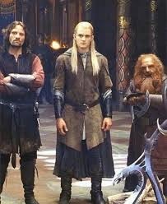


Spiderman
A full Spiderman outfit - Yes, perfectly OK.
A Spider man t-shirt and jeans – No, not OK.
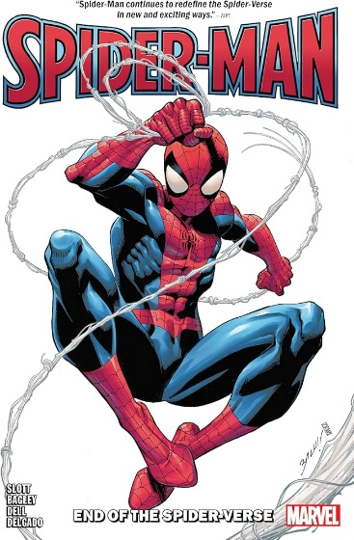
A penguin from the Penguin books logo – Yes, very creative and perfectly OK
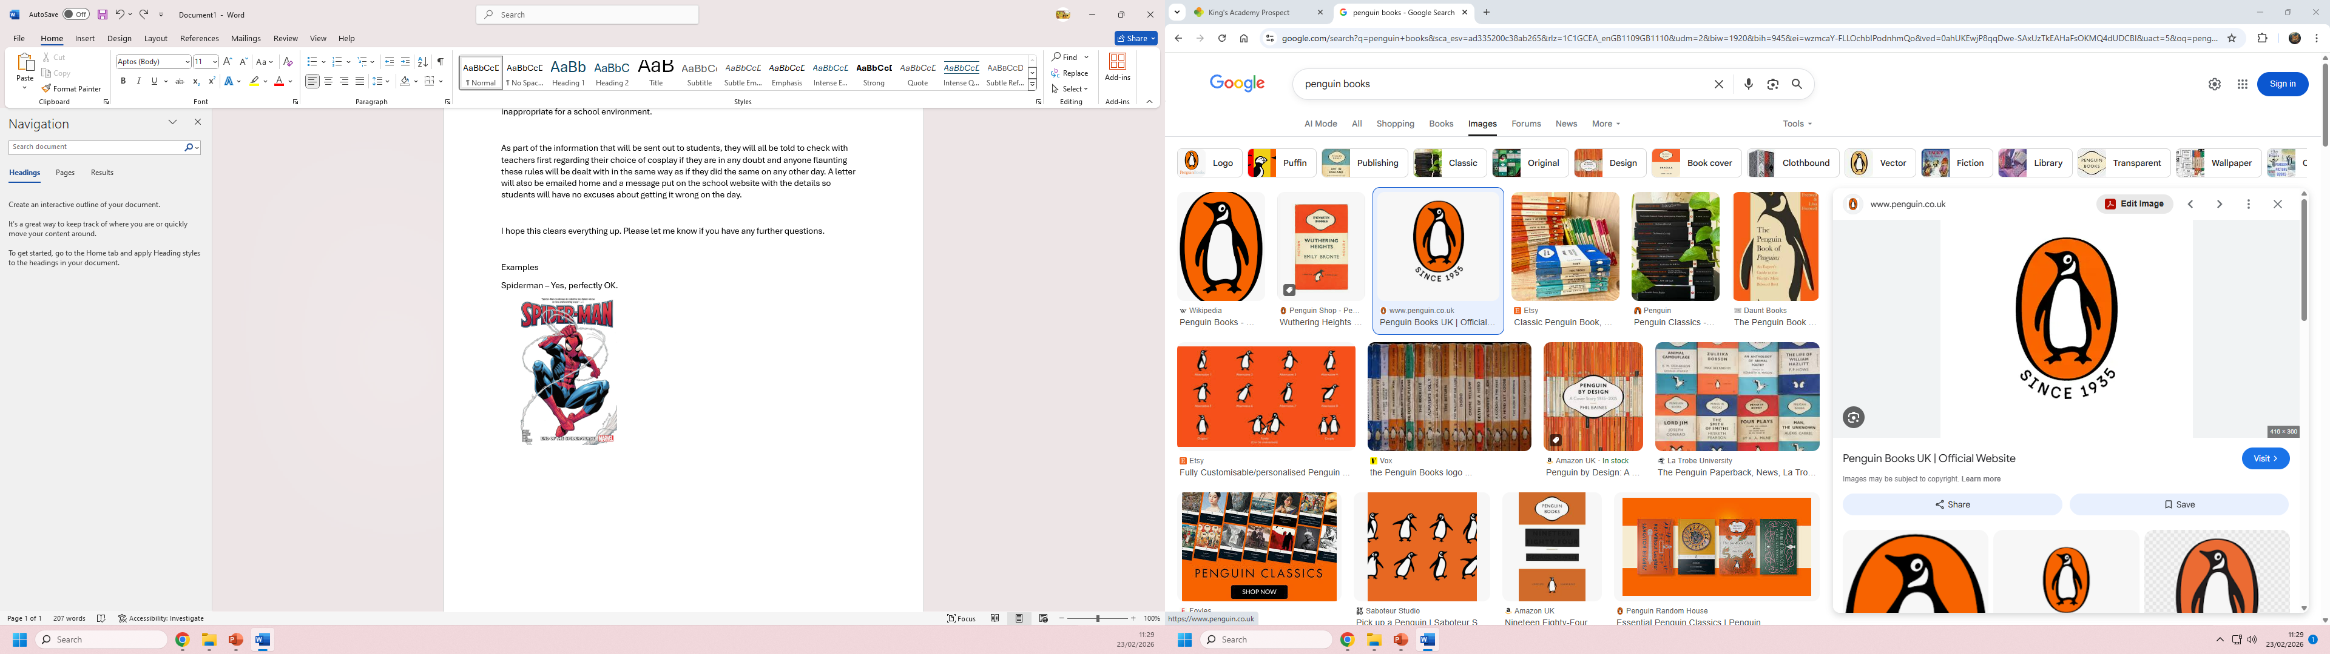

Where’s Wally – Perfectly OK if you have the red stripy top and some glasses.
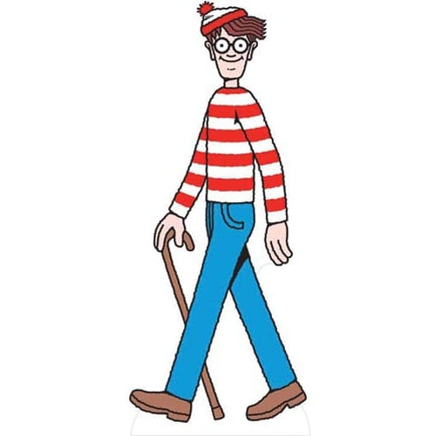

Diary of a wimpy kid / Horrid Henry – Not OK, not unless the clothing of Horrid Henry matches perfectly and preferably only if you have a copy of one of the books with you.

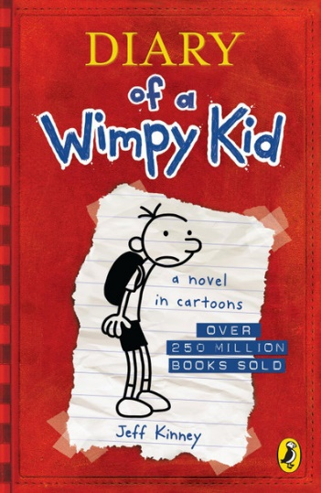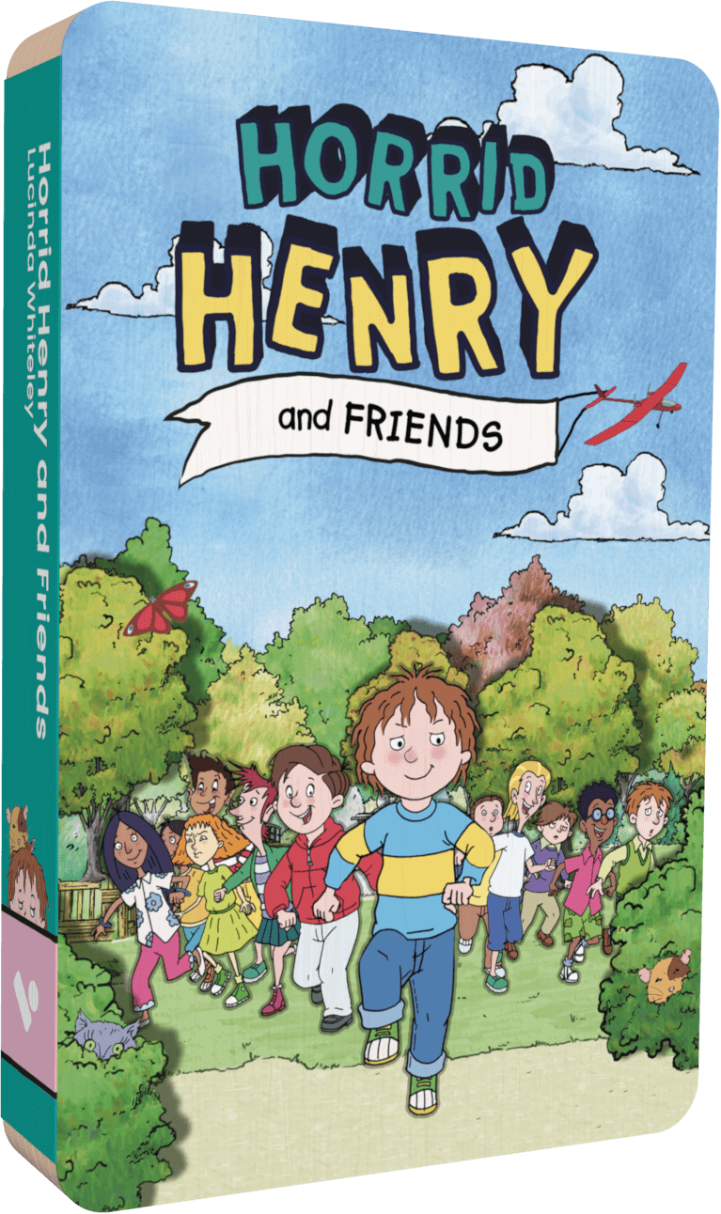

Sport stars biography / autobiography – No, afraid not. Please feel free to bring in a copy of the autobiography of your favourite sports star but this is a celebration of Reading, not sport. Sport’s clothing will not be allowed.

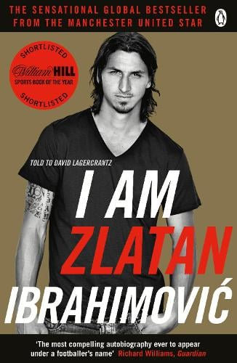

A random character wearing jeans and t-shirt in a book – No, afraid not. You need to make a genuine effort to dress up as a character from a book.

There may be exceptions, if you are in any doubt, please check with your tutor, Mrs Grove in the Library or Mr Jenkins in the Exams Office. It will always help if you are able to bring in a book where your character originates.

There is no pressure whatsoever to dress up on the day, you can simply arrive to school in your usual school uniform.

Thank you in advance for your co-operation with this and I hope you all have an enjoyable World Book Day.

KGA Prospect – WBD Committee

